Supplement

Protocol for a global cohort study: HernIas, Pathway and Planetary Outcomes for Inguinal Hernia Surgery (HIPPO)

NIHR Global Research Health Unit on Global Surgery
A full list of collaborating authors is shown in Appendix 1

Corresponding author:
Dr Maria Picciochi, NIHR Global Health Research Unit on Global Surgery, Institute of Applied Health Research, University of Birmingham, Birmingham B15 2TH, UK
m.picciochi@bham.ac.uk

Acknowledgments: This study was supported by NIHR Global Health Research Unit Grant (NIHR16.136.79) and a project research grant from Portuguese Hernia and Abdominal Wall Society (Sociedade Portuguesa de Hernia e Parede Abdominal). The funders had no role in study design or writing of this report. The views expressed are those of the authors and not necessarily those of the National Health Service, the NIHR or the UK Department of Health and Social Care.

Appendices

Appendix 1 – List of authors | Pages 1-34
Appendix 2 – Case report form | Pages 35-45
Appendix 3 – Hospital level survey
Appendix 4 - Definitions

Appendix 1: List of authors
Writing group (listed by country):
M Picciochi*, D Chaudhry*, M Elhadi*, I Jakaityte*, SZY Ooi*, AO Ademuyiwa, A Adisa, AE Agbeko, JA Calvache, D Ghosh, J Glasbey, PD Haque, E Harrison, B Kadir, SK Kamarajah, O Kouli, I Lawani, S Lawani, V Ledda, E Li, J Martin, D Nepogodiev, F Ntirenganya, O Omar, A Ramos-De la Medina, JFF Simoes, M Steinruecke, S Tabiri, A Bhangu
(*joint first authors)

Appendix 2: Case report form
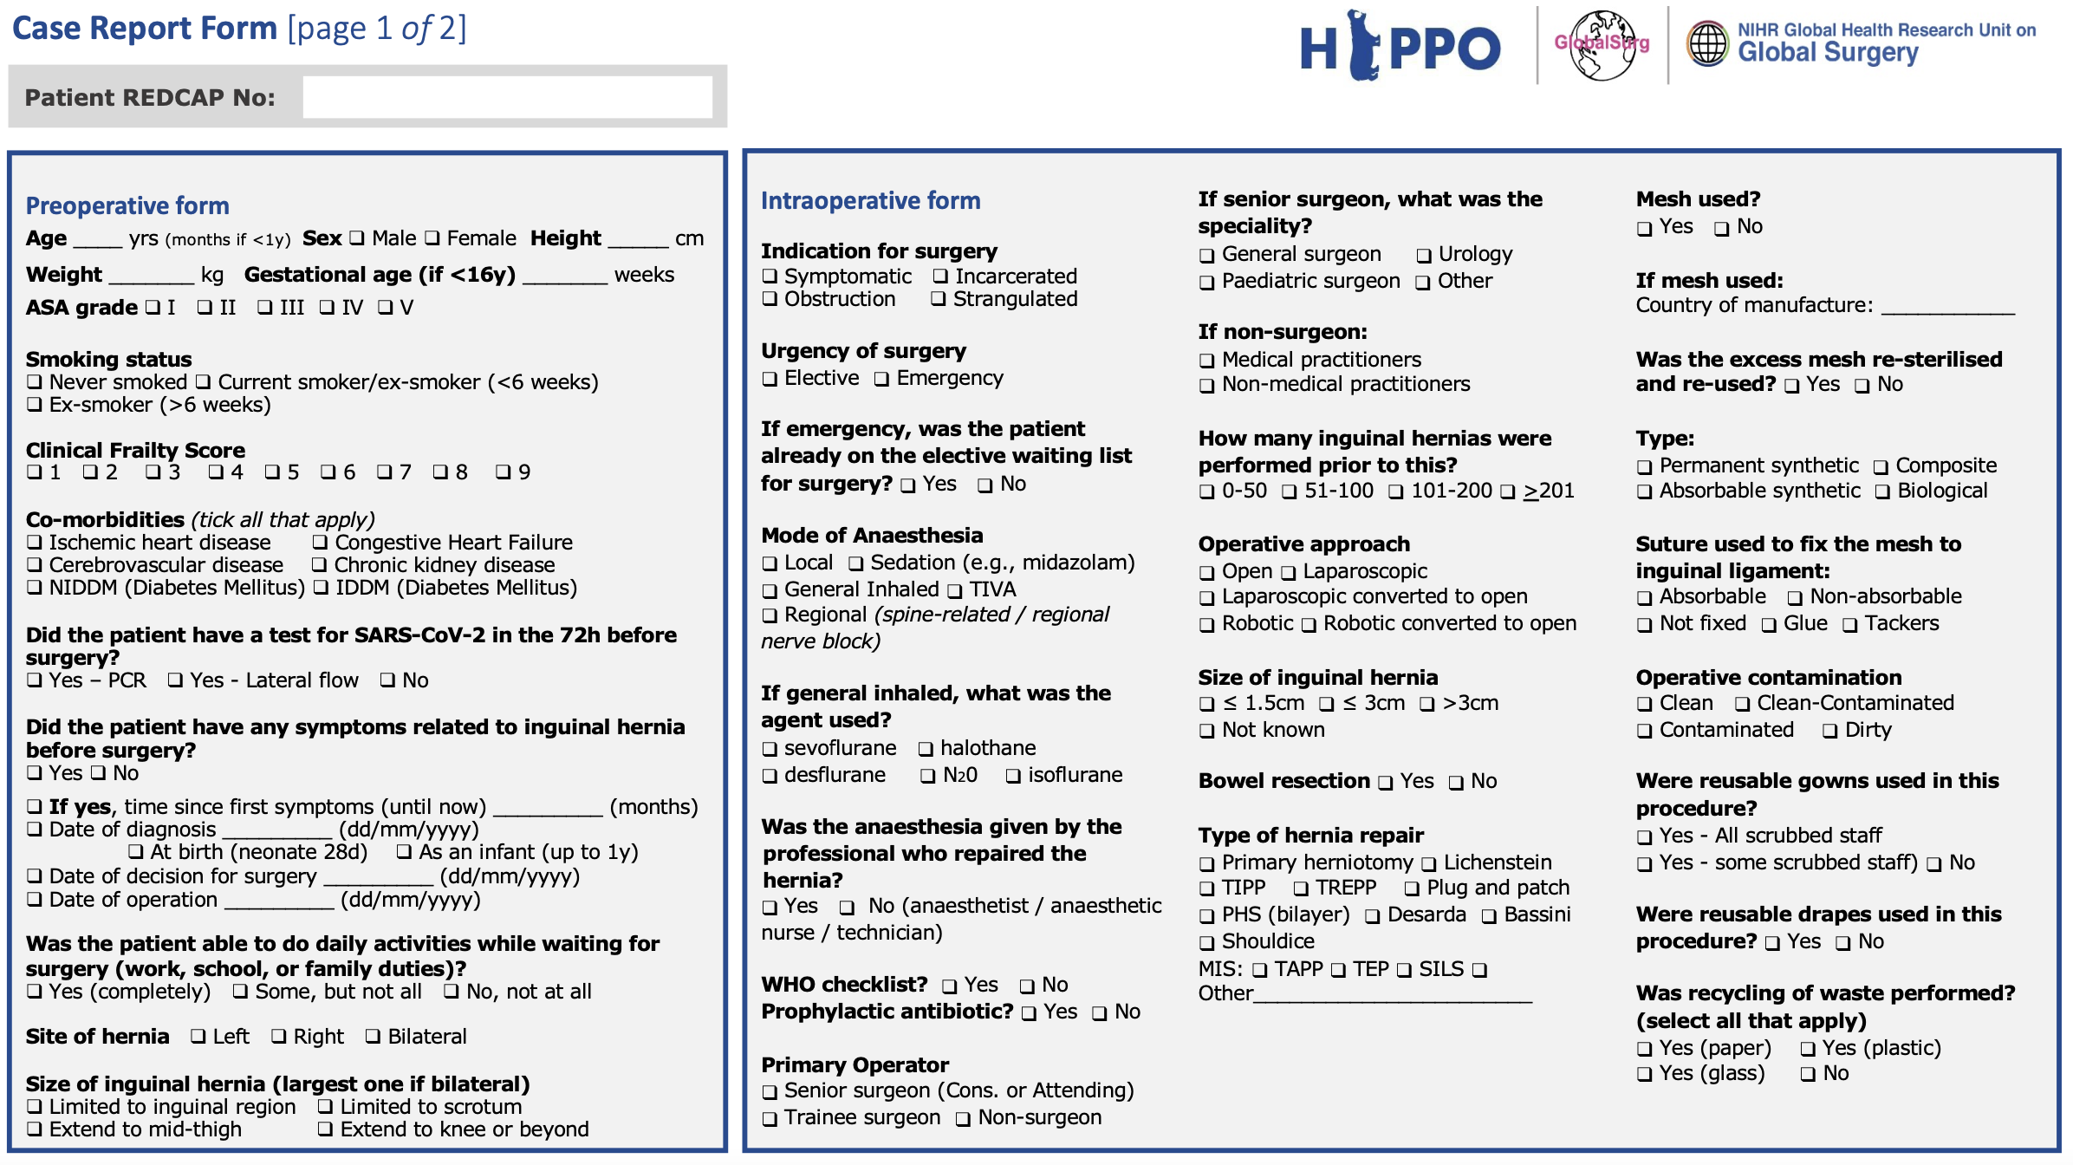

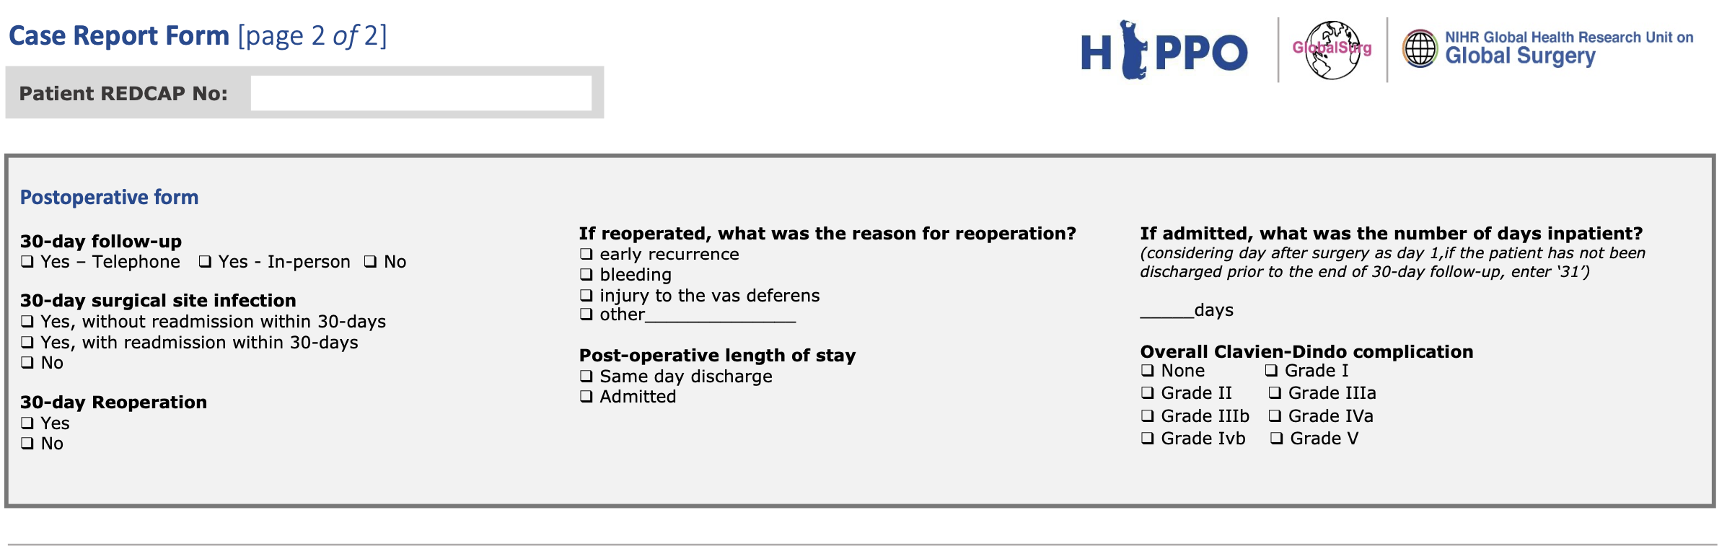

Appendix 3: Hospital-level survey

Variable | Options
Hospital type | - Primary level - few specialties, mainly internal medicine, obstetrics & gynaecology, paediatrics and general surgery, or just general practice. Limited laboratory services available and no specialised pathological analysis (i.e., 'district', 'rural', or 'community' hospital)  - Secondary level - more differentiated by function with as many as 5 to 10 clinical specialties, usually from 200 to 800 beds (i.e., 'regional', 'provincial' or 'general' hospital)  - Tertiary level - highly specialised staff and technical equipment, clinical services highly differentiated by function, may have teaching activities, usually from 300 to 1,500 beds (i.e., 'national', 'central', 'academic', 'teaching' or 'university' hospital)
Hospital ownership | - Government, publicly owned  - Private non-for profit organisation e.g., charity, NGO  - Private for-profit organisation  - Public-private partnership (partly funded by both)
Total hospital beds | (number)
Waiting lists management | - Yes, there is an electronic list  - Yes, there is a paper list  - No, there is no record of that
Emergency surgery provision | - No  - Yes - but patients are admitted for assessment only. All patients needing emergency surgery are transferred to another hospital.  - Yes - patients are admitted for assessment and can have emergency surgery on-site if needed. Emergency surgery is only available during the daytime.  - Yes - patients are admitted for assessment and can have emergency surgery on-site if needed. Emergency surgery is available 24 hours a day.
Day-case surgery unit available | - Yes  - No
Payment of surgical costs | - Insurance provided by the government (national or regional level)  - Insurance provided by employer (or household members' employer)  - Insurance that the patient has privately arranged and paid for  - Insurance but unknown how this was arranged  - External funds or grants awarded by charities/NGOs  - Out of pocket payments (patient paid the hospital directly)  - Other

Appendix 4: Definitions

Surgical site infection
Surgical site infection is defined at 30 days post-surgery using the Centers for Disease Control (CDC) definition of deep incisional or superficial incisional SSI as follows
- The infection must occur within 30 days of the index operation
- The infection must involve the skin, subcutaneous, muscular, or fascial layers of the incision
- The patient must have at least one of the following: purulent drainage from the wound; organisms detected by wound swab; diagnosed clinically or at imaging; wound opened spontaneously or by a clinician
- The patient has at least one of the following: pain, tenderness, localized swelling, redness, heat at the wound site, systemic fever (>38°C).

Clavien-Dindo complications
Adverse post-operative events may be classified in different ways:
- Failure of treatment - This occurs when the original surgery fails to achieve its intended benefits;
- Sequelae: The recognised consequences of a given procedure; for example, gut malabsorption following a large small bowel resection or immune deficiency following splenectomy.
- Complication: Any deviation from the normal post-operative course that has an adverse effect on the patient and is not either a treatment failure or sequel.

In the Clavien-Dindo classification ³⁵, the factor determining the severity of a complication is the treatment required. Consequently, a given complication may be graded differently depending on how it has been managed. For example, an anastomotic leak may be managed just with antibiotics if it is contained (grade II) or it may require re-operation under anaesthetic (grade IIIb).
Some other considerations:
- Intra-operative complications are not considered unless they have an adverse effect on the patient post-operatively. The only exception to this is intra-operative death; this is classified as grade V.
- All post-operative adverse events are included, even when there is no direct relationship to the surgery.
- All adverse events within the follow-up period (30 days) are included, even after following discharge.
- Diagnostic procedures are not included. For example, a diagnostic oesophagoduodenoscopy (OGD) to look for a source of bleeding without any intervention would not be considered a complication, but a therapeutic OGD with clipping of a bleeding vessel would be considered a grade IIIa complication. Since negative exploratory laparotomies are considered diagnostic procedures, they should not be recorded as complications.

Grade | Definition (examples listed in italics)
I | Any deviation from the normal postoperative course without the need for pharmacological (other than “allowed therapeutic regimens”), surgical, endoscopic or radiological intervention.  Allowed therapeutic regimens are: selected drugs (antiemetics, antipyretics, analgesics, diuretics and electrolyte replacement), physiotherapy and wound infections opened at the bedside but not treated with antibiotics.  Examples: Ileus (deviation from the norm); hypokalaemia treated with K; nausea treated with cyclizine; acute kidney injury treated with intravenous fluids.
II | Requiring pharmacological treatment with drugs beyond those allowed for  grade I complications. Blood transfusions and total parenteral nutrition are also included.  Examples: Surgical site infection treated with antibiotics; myocardial infarction treated medically; deep venous thrombosis treated with enoxaparin; pneumonia or urinary tract infection treated with antibiotics; blood transfusion for anaemia.
IIIa | Requiring surgical, endoscopic or radiological intervention, not under general  Anaesthetic (GA).  Examples: Therapeutic endoscopic therapy (do not include diagnostic procedures); interventional radiology procedures.
IIIb | Requiring surgical, endoscopic or radiological intervention, under GA.  Examples: Return to theatre for any reason.
IVa | Life-threatening complications requiring critical care management with single organ dysfunction, or neurological complications including brain haemorrhage and ischemic stroke (excluding TIA).  Examples: Single organ dysfunction requiring critical care management, e.g. pneumonia with ventilator support, renal failure with filtration; SAH; stroke
IVb | Life-threatening complications requiring critical care management with multi-organ dysfunction.

Clinical Frailty Score
Score | Level | Definition
1 | Very fit | People who are robust, active, energetic and motivated. These people commonly exercise regularly. They are among the fittest for their age.
2 | Well | People who have no active disease symptoms but are less fit than category 1. Often, they exercise or are very active occasionally, e.g. seasonally.
3 | Managing well | People whose medical problems are well controlled but are not regularly active beyond routine walking.
4 | Vulnerable | While not dependent on others for daily help, often symptoms limit activities. A common complaint is being “slowed up”, and/or being tired during the day.
5 | Mildly frail | These people often have more evident slowing, and need help in high order IADLs (finances, transportation, heavy housework, medications). Typically, mild frailty progressively impairs shopping and walking outside alone, meal preparation and housework.
6 | Moderately frail | People need help with all outside activities and with keeping house. Inside, they often have problems with stairs and need help with bathing and might need minimal assistance (cuing, standby) with dressing.
7 | Severely frail | Completely dependent for personal care, from whatever cause (physical or cognitive). Even so, they seem stable and not at high risk of dying (within ~ 6 months).
8 | Very severely frail | Completely dependent, approaching the end of life. Typically, they could not recover even from a minor illness.
9 | Terminally ill | Approaching the end of life. This category applies to people with a life expectancy <6 months, who are not otherwise evidently frail.

